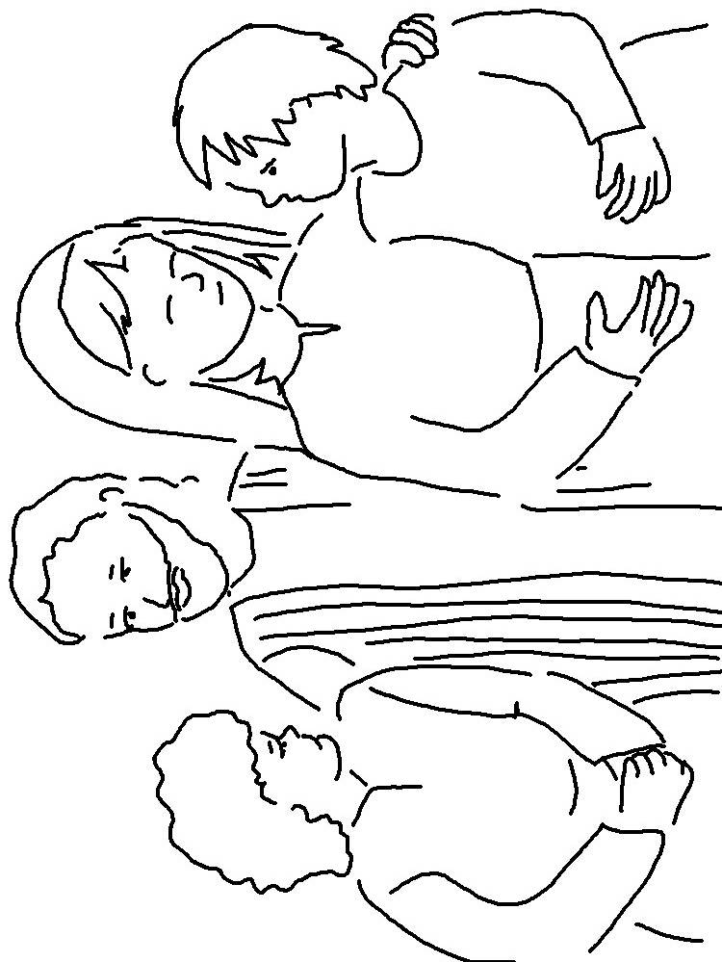
Do not _________. Do not lie. Do not _____________ one another.
Leviticus 19:11 _{NIV}

